**Multi - Dimensional Arrays**

**(1)** How many array elements are there given this declaration?

**int[][] array1 = new int[3][5];**

**(a) 15** (b) 13 (c) 8 (d) 6 (e) 16

**(2)** An m by n array contains m rows, n columns and m * n elements.

**(a) True** (b) False

**(3)** Execute the following code using Eclipse. Display a snapshot of the output.

**Source Code**

|  |
| --- |
| **public class Arrays {**  **public Arrays() {**  **}**  **public static void main(String[] args) {**  **float[][] a = new float[][] {{500, 200}, {100, 400}};**  **float[] b = new float[] {8, 6};**  **String[] s = new String[] {"cinema 1", "cinema 2"};**  **String[] t = new String[] {"Adults", "Children"};**  **int i,j;**  **System.*out*.println("\n\n");**  **System.*out*.println("Cinema Complex Attendance");**  **System.*out*.println("\n\n");**  **System.*out*.println(" \t\tAdults\t\t" + "Children");**  **System.*out*.println("\t\t_ _ _ _ _ _\t" + "_ _ _ _ _ _\n");**  **for ( i = 0 ; i <= 1 ; i++ )**  **{**  **for ( j = 0 ; j < 1 ; j++ )**  **System.*out*.println(s[i] + " \t" + a[i][j] + "\t\t" + a[i][j + 1]);**  **}**  **System.*out*.println("\nCinema Complex Admission\n");**  **for ( i = 0 ; i <= 1 ; i++ )**  **System.*out*.println(t[i] + "\t$" + b[i]);**  **System.*out*.println("\n\n");**  **System.*out*.println("Cinema Complex Revenue\n\n");**  **for ( i = 0 ; i <= 1 ; i++ )**  **{**  **for ( j = 0 ; j < 1 ; j++ )**  **System.*out*.println(s[i] + "\t$" +**  **(a[i][j] * b[j] + a[i][j + 1] * b[j + 1]));**  **}**  **}**  **}**  **Output** |

**(4)** Modify the code in **Exercise (3)** to solve the following exercise. Place a snapshot of the output below the code!

A movie complex has three separate theaters: Cinema 1 , Cinema 2 and Cinema 3 . The attendance Monday for the entire complex is given in the matrix below.

|  |  |  |  |  |
| --- | --- | --- | --- | --- |
|  |  | Adults | Children |  |
| Cinema 1 |  | 029 | 149 |  |
| Cinema 2 |  | 059 | 043 |  |
| Cinema 3 |  | 147 | 011 |  |

If the admission price for each cinema is $ 4 for children and $ 8 for adults, find the total revenue that was collected Monday at the theater complex.

Hint: multiply the above matrix *A* , which contains the total tickets sold, by column matrix *B* ,containing the admission prices, and then compute the matrix product *A B* .

**Source Code**

public class Arrays {

public Arrays() {

}

public static void main(String[] args) {

// array for attendance

float[][] a = new float[][] {{29, 149}, {59, 43}, {147, 11}};

// array for ticket price

float[] b = new float[] {8, 4};

String[] s = new String[] {"cinema 1", "cinema 2", "cinema 3"};

String[] t = new String[] {"Adults", "Children"};

int i,j;

System.out.println("\n\n");

System.out.println("Cinema Complex Attendance");

System.out.println("\n\n");

System.out.println(" \t\tAdults\t\t" + "Children");

System.out.println("\t\t_ _ _ _ _ _\t" + "_ _ _ _ _ _\n");

// display array values

for ( i = 0 ; i <= 2 ; i++ )

{

for ( j = 0 ; j < 1 ; j++ )

System.out.println(s[i] + " \t" + a[i][j] + "\t\t" + a[i][j + 1 ]);

}

// display ticket values

System.out.println("\nCinema Complex Admission\n");

for ( i = 0 ; i <= 1 ; i++ )

System.out.println(t[i] + "\t$" + b[i]);

// display revenue

System.out.println("\n\n");

System.out.println("Cinema Complex Revenue\n\n");

for ( i = 0 ; i <= 2 ; i++ )

{

for ( j = 0 ; j < 1 ; j++ )

System.out.println(s[i] + "\t$" +

(a[i][j] * b[j] + a[i][j + 1] * b[j + 1]));

}

}

}

**Output**

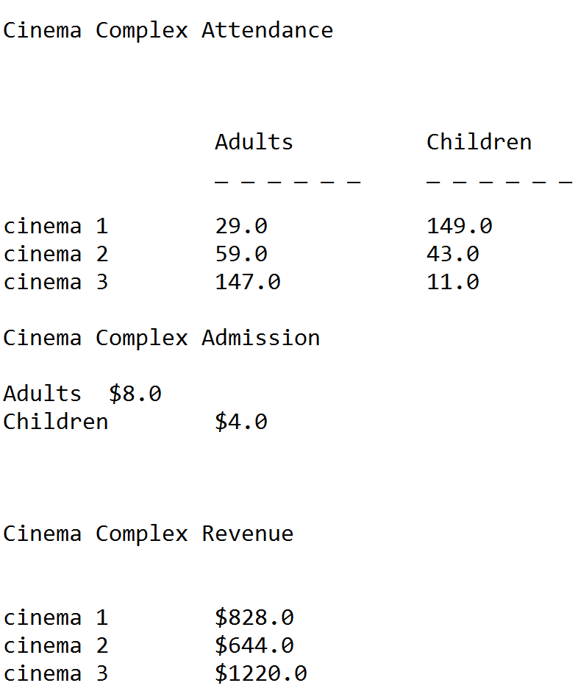

**(5a)** Provide comments statements for each line of the Java Code shown below (i.e., give the line’s purpose). [Note: you have seen this code in Week 5]

**public** **class** CharacterInfo

{

**public** **static** **void** main(String[] args)

{

// delare character variable

**char** aChar = 'C';

//display the character

System.***out***.println("The character is " +aChar);

// state character is uppercase

**if**(Character.*isUpperCase*(aChar))

System.***out***.println(aChar + " is uppercase");

**else**

System.***out***.println(aChar + " is not uppercase");

//state character is lowercase

**if**(Character.*isLowerCase*(aChar))

System.***out***.println(aChar + " is lowercase");

**else**

System.***out***.println(aChar + " is not lowercase");

// force character to be lowercase

aChar=Character.*toLowerCase*(aChar);

System.***out***.println("After toLowerCase(), aChar is " + aChar);

//force character to be uppercase

aChar=Character.*toUpperCase*(aChar);

System.***out***.println("After toUpperCase(), aChar is " + aChar);

// state whether the character is a letter or a digit

**if**(Character.*isLetterOrDigit*(aChar))

System.***out***.println(aChar + " is a letter or digit");

**else**

System.***out***.println(aChar + " is neither a letter nor a digit");

// state whether the white character is a whitespace java character or not

**if**(Character.*isWhitespace*(aChar))

System.***out***.println(aChar + " is whitespace");

**else**

System.***out***.println(aChar + " is notwhitespace");

}

}